

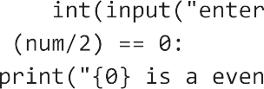

1. Phyton

Python is a computer programming language often used to build websites and software, automate tasks, and conduct data analysis. Python is a general-purpose language, meaning it can be used to create a variety of different programs and isn’t specialized for any specific problems.

